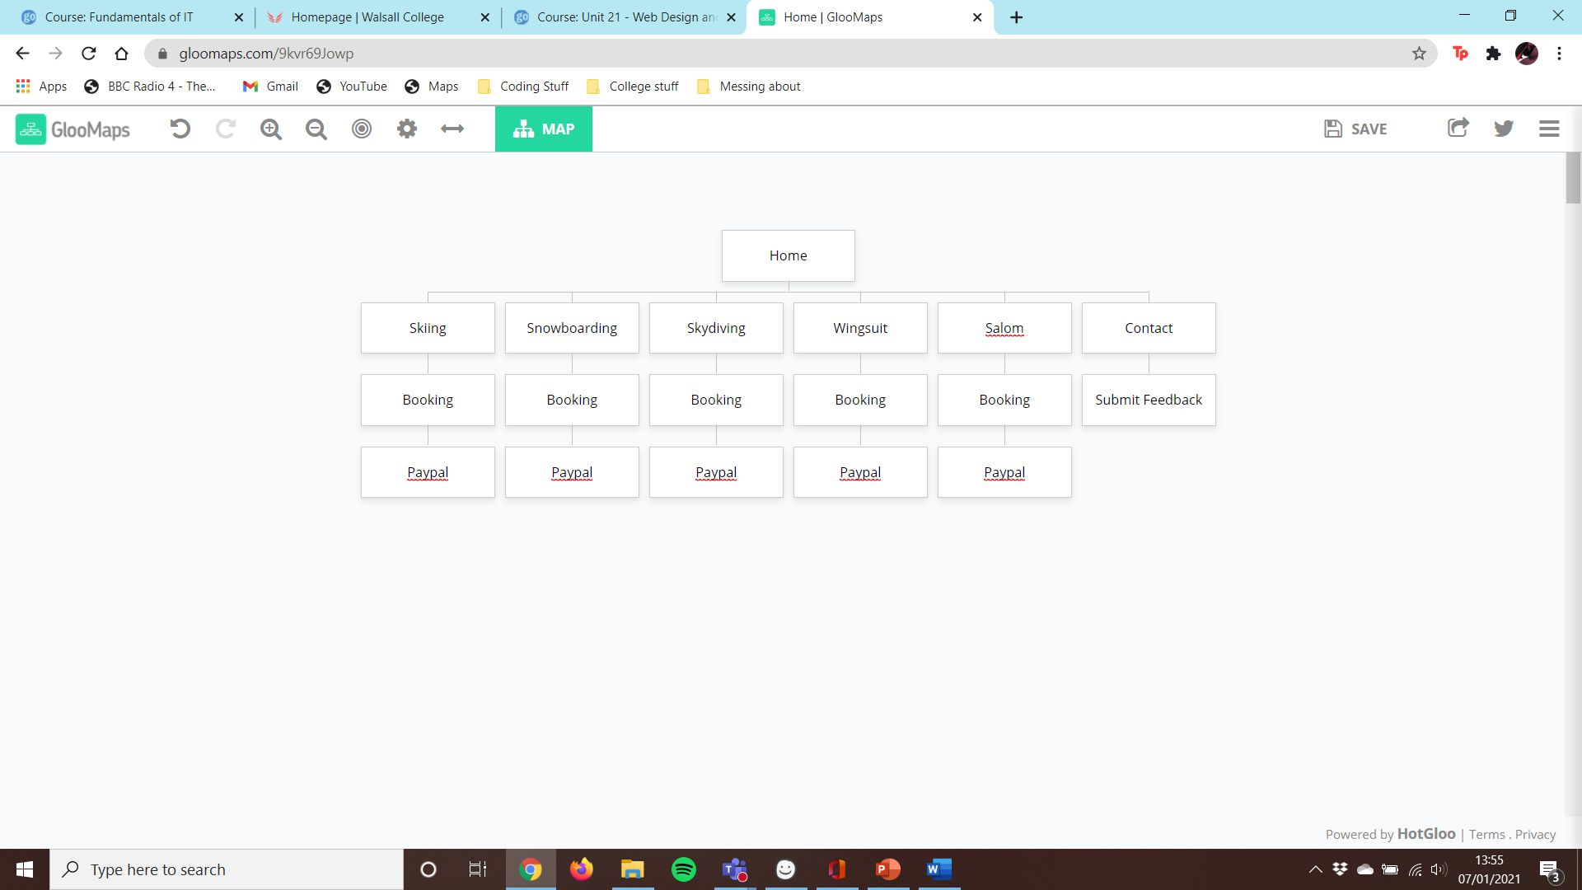Sitemap

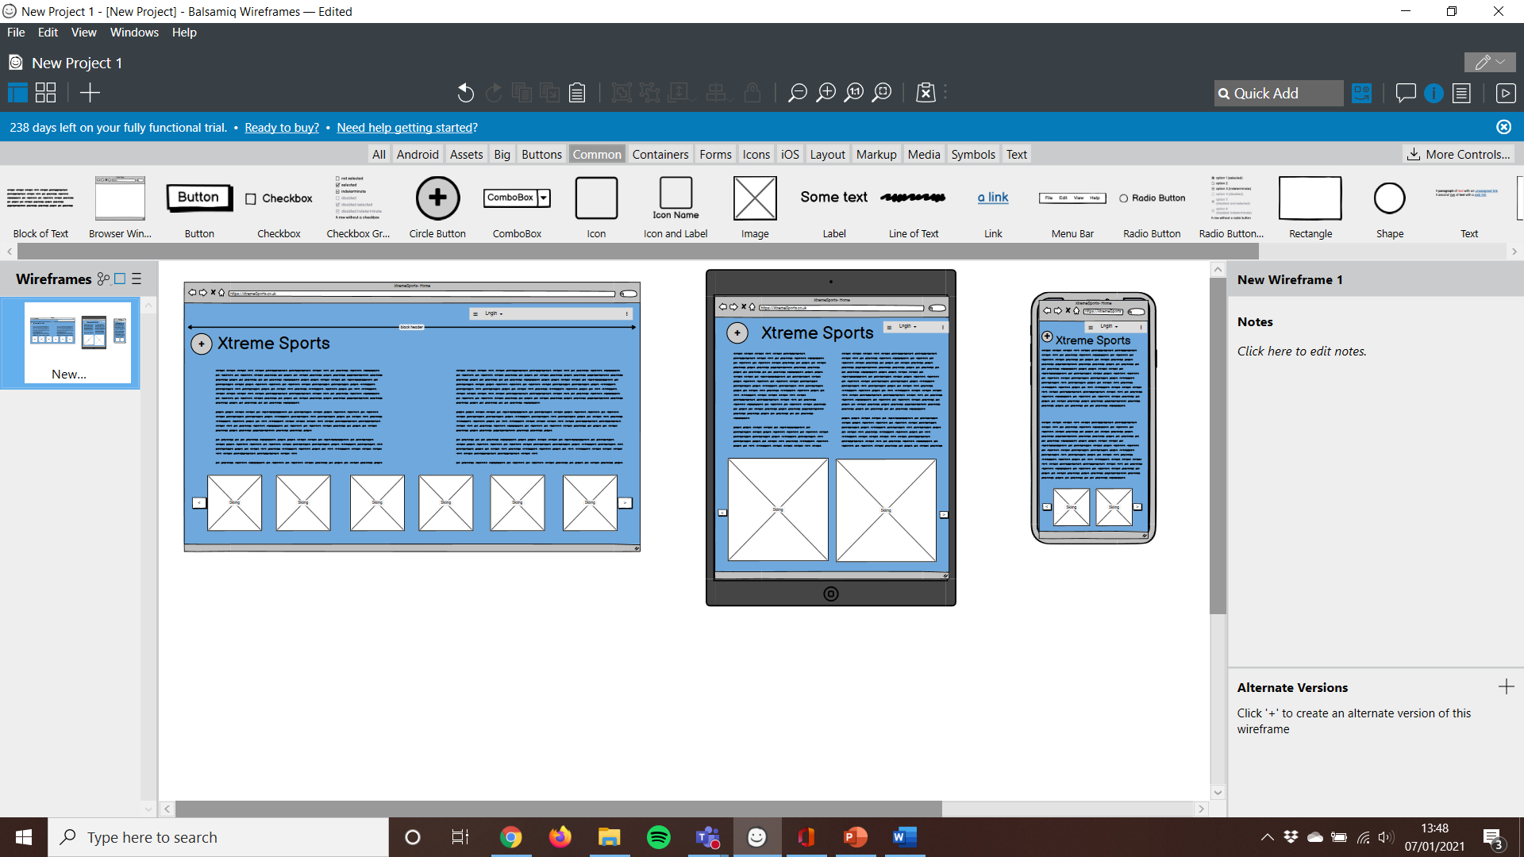Balsamiq Map

(Meant to have a black header but I didn’t know how to do that in Balsamiq)